
Supporting Material
Session 1: Design Approaches and Requirements Analysis. Reference for Activities 1 and 2.
Fictional organisation and synthetic data: the organisation, its people and its figures are invented for teaching.
Use the section an activity step or a 'Stuck?' line names. Activity 1 needs only section 4; sections 1 to 3 are the method behind it. Sections 5 to 9 support Activity 2. The worked examples use a different organisation, Riverside Leisure Centre (also fictional), so you can see each method before you apply it to Kestrel Moor Homes.

1. Four design approaches at a glance
Approach | Focus | Typical first artefacts | Fits when | Watch out for
User-centred | The people who will use the system: research, design, test with them | Personas, task flows, prototypes tested with users | Users vary and their needs are not yet clear | Research takes time; users cannot judge the back end
Iterative | Thin slices, each built, tried and adjusted from feedback | A release plan for a thin slice, with a feedback measure | Priorities are uncertain and feedback is quick to get | Slices drift without a direction; rework adds up
Component-based | Parts with clear interfaces, so a part can be replaced or reused | A component diagram with named interfaces | Parts connect to systems or suppliers that may change | Interfaces need agreeing early; many parts add overhead
Domain-driven | A model of the business rules, built with the experts in one shared language | A concept map and glossary agreed with experts | Rules are complex and terms clash between teams | Needs experts' time; heavy for a simple system

These are design approaches, not programming paradigms. Object-oriented, procedural, event-driven and functional describe how code is structured; they decide how you write the classes, not what you design first or how you check it.

2. Choosing with evidence: five questions
Ask | A strong answer points towards | Evidence to look for
How clear are the requirements? | User research and early testing when needs are unclear or disputed | Stakeholder quotes about what users want; complaints; groups nobody has asked
How complex is the domain? | Modelling the domain when rules, special cases and clashing terms pile up | Policies with exceptions; words that different teams use differently
What is likely to change? | Parts behind interfaces when a supplier or system may be replaced | Contracts, integrations, requirements about replacing parts
How involved can stakeholders be? | Short feedback cycles and user testing when users and experts are available | Panels, pilots, named experts, release dates
What must be documented? | Written decisions, whatever the approach, when work is regulated or audited | Laws, policies, audit or sign-off requirements

Evidence is a quote from the brief (a stakeholder, a policy rule or a requirement) or a figure from the data. Say where it comes from: the part of the brief and the person or rule, or the column and filter. A preference, such as 'I like agile', is not evidence.

3. Worked example: a leisure-centre booking app
Brief extract. Riverside Leisure Centre wants a class booking app. Members aged 16 to 90 book fitness classes, and many say the current app is confusing. The payment provider's contract ends next year and a new provider will be chosen. The manager wants online booking for one class type by January, then to add more. Booking rules are simple: one place per member per class, and members can cancel up to 2 hours before.
Part of the system | Approach | Evidence from the brief | First artefact and what it shows
Member booking journey | User-centred | "Members aged 16 to 90"; "many say the current app is confusing" | A booking task flow tested with five members of different ages, showing where they hesitate
Payments | Component-based | "The payment provider's contract ends next year" | A payment interface (pay, refund, check status) that the booking code calls, so a new provider means one new adapter
First release | Iterative | "one class type by January, then to add more" | A release plan for slice one, measured by the share of that class's bookings made online
Booking rules | Not domain-driven | "Booking rules are simple" | A one-page glossary (class type, class session, place, waiting list) is enough

Approaches rejected, with reasons: for payments, user-centred was rejected because testing with members cannot reduce the cost of changing provider; for the first release, domain-driven was rejected because the rules are few and simple.
Notice the shape: part of the system, approach, the evidence that decided it, and an approach rejected with its reason.

4. Four project situations (Activity 1)
Each situation is one part of the Kestrel Moor portal. The extracts are quoted word for word from the Case Brief or the Repair Requests data, so you do not need the brief open. None of them names an approach: that is your decision, and more than one approach may be defensible.

A. Reporting a repair
Source | Extract
Part 1, Phase 1 scope | "Tenants report a repair online, with screens designed for mobile phones first, with up to three photos, and receive a reference number straight away."
Part 2, Maureen Hughes, Chair of the Tenant Panel | "A lot of our members are older and some won't use an app, full stop, so don't take the phone away. ... Half the forms we get have tiny grey writing."
Data, vulnerability_note | KMR-26-0061 and KMR-26-0144: "Deaf: contact by text only".

B. Jobs for operatives and contractors
Source | Extract
Part 1, Who does the work | "Gas and heating work and roofing go to two external contractors."
Part 2, Priya Nair, IT and Digital Lead | "The housing management system has a repairs API, but it is slow and we cannot change it, so the portal will need its own layer in front of it."
Part 5, requirement MNT-2 | "Replacing a contractor, or the operative scheduling system, must affect only the part of the system that talks to it."

C. Priority and damp and mould rules
Source | Extract
Part 4, Repair Priority Policy, Emergency | "no heating at all between 1 October and 30 April inclusive, or at any time of year if the household has a recorded vulnerability"
Part 4, Damp and mould rule | "If the same home has reported damp or mould before, the new report is linked to the earlier ones and the case goes to the Damp and Mould Lead."
Data dictionary, repeat_report | "Y if contacts_about_issue is 2 or more."

D. Photos with a report
Source | Extract
Part 2, Dev Malhotra, Head of Repairs | "Our biggest cost is going back. An operative turns up, it's the wrong trade or he hasn't got the part, and we book another visit. If tenants could send a photo we'd send the right person first time."
Data, first_time_fix | 34 of the 123 completed jobs are N (not fixed on the first visit).
Part 5, Tom Reid, Data Protection Officer | "a photo of a bedroom can show people, medication or letters."

5. Reading a brief: seven things to pull (Activity 2, step 1)
What to pull | Ask yourself | Riverside Leisure Centre example
Actors | Who does something, or has something done for them? | Members, receptionists, instructors
Goals | What does each actor want to achieve? | Book in seconds and know they have a place
Things (entities) | Which nouns must the system know about? | Class, class session, studio, place, booking
Rules | What must always, or never, happen? | A member may hold three bookings at once
Constraints | What limits how we can build it? | Must use the existing membership database
Pain points | Where does it go wrong today, and for whom? | Members ring reception to ask about gaps in full classes
Open questions | What does the brief not settle, and who could answer? | How long a waiting-list offer stays open (bookings manager)

Read once for the story, then again with a pen, tagging each sentence with one of the seven. For the step 1 table, a requirement is something the system must do (it usually comes from a goal or a pain point); a constraint limits how you can build it (existing systems, sign-in, team size, dates).

6. Concept maps and task flows (Activity 2, steps 3 and 4)

Concept map: rules of thumb
• Each box holds a noun from the client's world (Member, Booking), not a screen, button or database table.
• Every line carries a verb, so the link reads as a sentence: Member makes Booking.
• Split concepts when the business treats them differently: Class type (Spin) and Class session (Spin on Tuesday at 18:00).
• About 10 concepts is plenty for a first map. Leave out anything you cannot connect.
• Use the stakeholders' words. If two teams use different words for one thing, note both and add an open question.
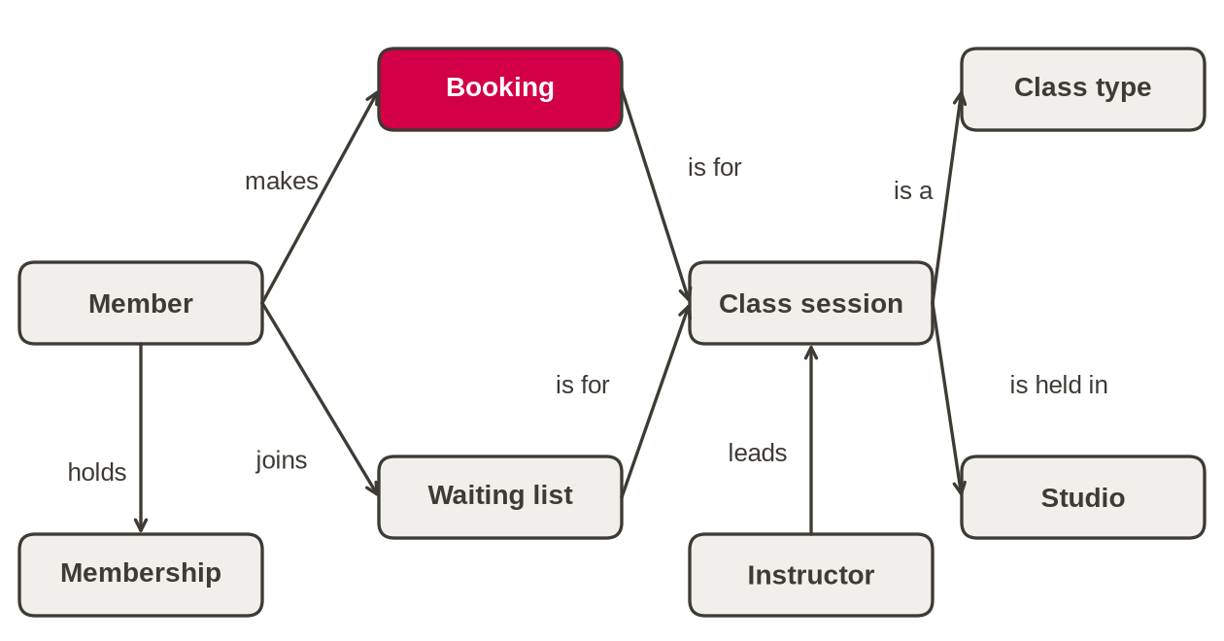
Figure 1. Concept map for Riverside Leisure Centre bookings (8 concepts, a verb on every line).

Task flow: rules of thumb
• One person, one goal, steps in order, written from that person's point of view.
• Start with what they notice or want; end when their goal is met.
• Show a decision as a diamond with labelled branches (yes, no).
• Draw today's flow first: its waits, repeats and dead ends are what the new flow must remove.
• Keep system steps out: 'database saves booking' belongs in a sequence diagram, which comes in Session 4.
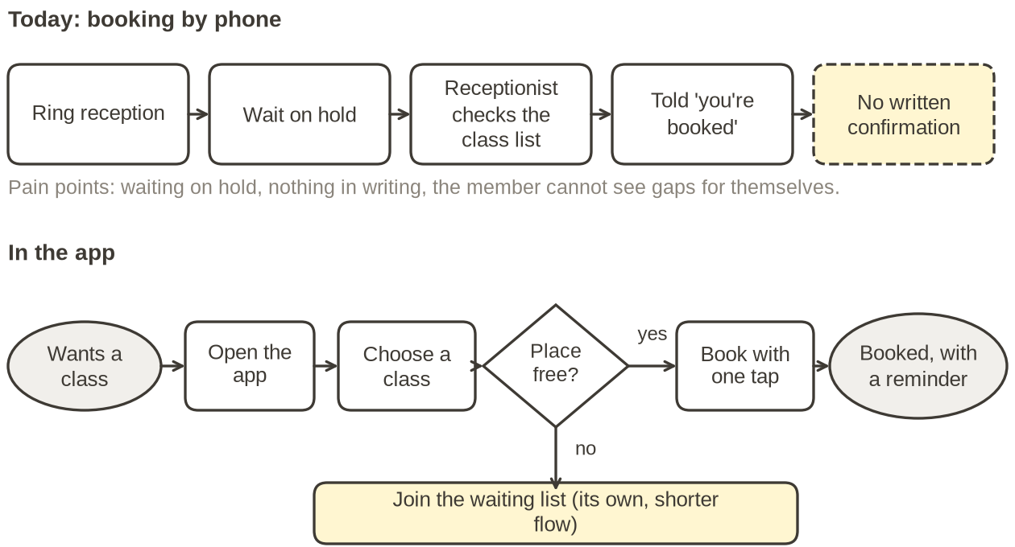
Figure 2. Today's flow and the app flow for booking a class at Riverside Leisure Centre.

7. Using the request data (Activity 2, step 2)
Kestrel Moor Homes - Repair Requests.xlsx, sheet Requests: 150 requests received from 1 September to 12 October 2026. The Data dictionary sheet explains every column. Tenant and property references are pseudonymous, so there are no names.

How to filter
1 Excel desktop or Excel for the web: click any cell in the header row, then Data, Filter. Each header gets a drop-down arrow.
2 Click the arrow on a column, untick Select All, tick the values you want, then OK.
3 After filtering, select the cells of a number column: the status bar at the bottom shows their Count, Average and Sum. Check that the Count matches the number of rows the filter shows. For the largest value, sort the column largest to smallest, or right-click the status bar and tick Maximum.
4 Clear the filter from the same drop-down before you start the next question.
5 No spreadsheet application: open the CSV file of the same name in any spreadsheet tool, or ask your partner to share their screen.

The four columns named in step 2
Column | What it means (from the data dictionary)
category | Repair category chosen by the person who logged the request.
priority_assigned | Priority given when the request was triaged: Emergency, Urgent or Routine (see the Repair Priority Policy in the Case Brief, Part 4).
status | Completed or Open at the extract date (16 October 2026).
tenant_description | The problem in the tenant's own words, as typed or as noted by the adviser.

Worked check on a different question
Claim in Case Brief Part 1: housing officers log repairs "usually the next working day". Filter channel to Housing officer: 14 requests. The status bar for hours_report_to_triage shows an average of 20.2 hours; sorting the column shows the longest is 33.6 hours. The column measures logging plus time waiting for triage, so it cannot prove when officers logged. Verdict: the data is consistent with the brief. Write down the filter, the column and the figure, so someone else can check it.
In step 2 you use the same method to find things the brief does not tell you. Other columns are explained on the Data dictionary sheet, and you may filter any of them. Keep the request IDs or the count you used: they become the evidence for your open questions.
The data is synthetic, but treat it as real: do not paste it into AI tools or share it outside the session.

8. Writing an evidenced open question (Activity 2, step 5)
Part | What to write
To | A named stakeholder who can answer: name and role (Case Brief Part 2 lists them)
Question | One open question (how, what, who, when), about something the brief does not settle
Evidence | A request ID, a count from the data with its filter, or a short quote from the brief with its part
Why it matters | One line on the design decision that depends on the answer

Riverside Leisure Centre example. To: the bookings manager. Question: how long does a member have to accept a waiting-list place before it is offered to the next person? Evidence: the brief says places are 'offered' but gives no time limit. Why it matters: the app needs a timer and a reminder, and the flow changes if an offer can lapse.
Check each question: it names someone who can answer; it asks one thing; its evidence can be checked by someone else; it is not an opinion ('Is the inbox bad?') or an assumption ('Tenants will use the app').

9. draw.io quick guide and the no-tool route
1 Open app.diagrams.net in your browser (no account needed), choose File, Open from, Device, and pick the starter file (Session 1 - Concept map and task flow (starter).drawio), after saving your own copy from the Files tab. The draw.io desktop app works the same way.
2 Drag shapes from the General panel on the left; double-click a shape to type in it.
3 Hover over a shape and drag one of its blue arrows to another shape; double-click the line to label it.
4 Use the page tabs at the bottom to move between Concept map, Task flow and Open questions.
5 Save with File, Save as, and choose Device. Keep the .drawio ending so the file reopens as a diagram.
No draw.io: use PowerPoint shapes and connectors (one slide per page), or draw on paper and photograph it. Post the file or photograph in the breakout chat before the room closes, so you keep it. This can be portfolio evidence if your skills coach agrees it shows your own work.

